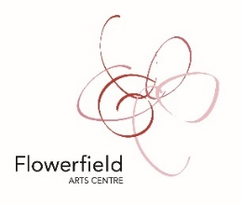
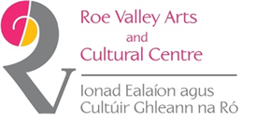
CAUSEWAY CHRISTMAS CREATIVES 2020

As we cannot host our annual Flowerfield Christmas Craft Fair this year, we want to continue to support creatives by showcasing your work via our Flowerfield Arts Centre & Roe Valley Arts and Cultural Centre social media feeds and websites. An artist/maker will be featured daily on our social media feeds and each selected creative will be included in a virtual Christmas Fair on our websites and will include information on you and your creative work, image(s) and information on how people can purchase your work (website, facebook page or blog etc).
We hope that some applicants will also be able to host short videos to introduce yourselves and possibly livestream a demo of your creative process. If you are interested in this, please indicate in the relevant section of form.
In order to be included:
- You must be a professional artist/maker
- Preferably living or working in the Causeway Coast & Glens Borough Council (*we will prioritise artists/makers within our borough and those who have participated in our previous Craft Fairs but you may not be excluded solely if you do not meet this criteria)
- Complete this form and return to Desima.Connolly@causewaycoastandglens.gov.uk
- Along with a minimum of four high-resolution images of your work
- BY THURSDAY 3 DECEMBER, 5PM

YOUR NAME
YOUR CONTACT DETAILS
ARE YOU LIVING OR WORKING WITHIN THE CAUSEWAY COAST & GLENS BOROUGH? *We will prioritise creatives based within our borough but you will not be excluded solely because you may be based outside the area
A MAXIMUM OF 300 WORDS ABOUT YOUR CREATIVE WORK
WHERE CAN PEOPLE PURCHASE YOUR WORK?
ARE YOU INTERESTED/WILLING TO HOST A SHORT VIRTUAL VIDEO OR DEMO? (*we can offer a fee for virtual demos)

Thank you!

